HARDCAT DATA CAPTURE
USER GUIDE


KZN PROVINCIAL TREASURY

Contents Page

- Objective ……………………………………………………….. 2
- Hardcat Forms ………………………………………………………….. 2
- Accessing Hardcat………………………………………………………. 3
- Data Capturing Process…………………………………………………. 3
- Creating an Asset Record ………………………………………………. 5
- Creating a Financial Asset Record ……………………........................... 8
- Recording Asset Preset Information ……………………......................... 9
- Attaching files…………………………………………………………… 10
- Monitoring Supplier Maintenance contracts ……………………………. 11
- Hardcat List with built in search…………………………………………. 13
- The Asset Type Key …………………………………………………….. 15
- To find an asset ………………………………………………………….. 17
- The copy key …………………………………………………………….. 17
- The Delete Key ………………………………………………………….. 17
- Transfer/Moving Assets ………………………………………………….. 18
- Creating an Asset Record via Purchasing Module……………………….. 19
- Reporting…………………………………………………………………. 23

- Objective
Assist and guide KZN Provincial Hardcat users to:

- Create an asset record.
- Edit an asset record.
- Monitor Supplier Maintenance contracts.
- Attaching assets that have component or sub-component association.
- View asset history.
- Draw reports.

- Hardcat Forms

Hardcat Asset Addition Form (Annexure A)

This form is completed upon receipt of asset. Once it has been completed and signed, the details are then captured on to the system. NB: Please complete the form accurately and in full. File the form in a secure place once you have captured everything.

Hardcat Transfer Form (Annexure B)

This form is to be completed whenever there is transfer of assets from with the same department (e.g. from one directorate to another or one region to another).

Hardcat Disposal/ Scrapping/ Write-off Form (Annexure C)

This form is completed whenever there a disposal / scrapping / write-off of an asset.

Hardcat User Application Form (Annexure D)

A new user will complete and sign the Hardcat User Application Form to be created on the Hardcat System.

- Accessing Hardcat

To gain access to Hardcat, a user must be registered.
Logging On

- To start Hardcat, click on the Black Cat icon on your Desktop. The Login Screen below will appear.
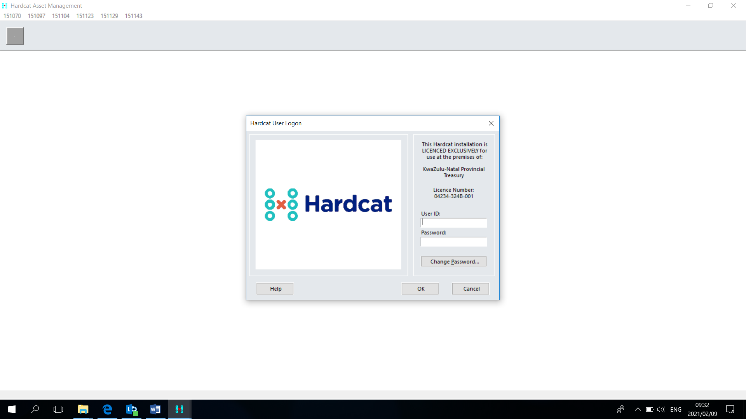

- Click in User ID and enter your allocated User ID Code.
- Click in Password and enter in your allocated Password Code
- To change password , click in change password field
- Press Enter or click on ‘OK’ to confirm.
- You should now have access to the Hardcat Main Menu.

- Data Capturing Process

DATA CAPTURING PROCESS: ASSETS ADDITION via BARCODING

When an asset has been delivered accompanied by the delivery note, and Goods Received in good condition note, yet no invoice has arrived, no data capturing should be done on Hardcat System.

When the invoice has arrived and the physical asset has been delivered, the following must be done:

- The asset must be bar-coded/tagged accordingly, using the prescribed metal bar-codes.

- The new asset addition form (Annexure A) must be completed fully and signed by the
responsible officials (explanatory notes on completion of the asset addition form are appended at the back of the form)

- After the completion of the asset addition form, the new asset must be captured on Hardcat System with the very same information that has been captured on the asset addition form.

NB: no asset should be captured without a complete and signed asset addition form

- Generate an individual asset detail report to confirm the correctness of the information captured or that asset.
Click List of assets, locate the captured asset from the list of assets by the barcode number, click on the asset, or highlight the asset, click send and click view, then click print.

- The asset addition form and the generated individual asset detail report should be stapled together and filed for audit purposes by asset management unit.

DELIVERING PROCESS: ASSET ADDITION via PURCHASING MODULE

When the asset has be purchased via Hardcat Purchasing Module, and an option to automatically create the asset on delivery was selected by the purchase order capturer, there will be no need capture the new asset on Hardcat via Bar-coding (Data capturing), this asset will be delivered on the system.

- When the physical Asset is delivered accompanied by the delivery note, and Goods Received in good condition note, but no invoice has arrived, you can deliver the asset on Hardcat but, no capturing of invoice details should be done.
- But first you need to barcode/tag the new asset accordingly.
- Complete the new asset addition form (Annexure A 07/08, with explanatory notes at the back of it) completely and get it signed, and
- Deliver the asset on Hardcat.
- Generate an individual asset detail report to confirm the correctness of the information captured or that asset.
Click List of assets, locate the captured asset from the list of assets by the barcode number, click on the asset, or highlight the asset, click send and click view, then click print.
- The asset addition form and the generated individual asset detail report should be stapled together and filed for audit purposes by asset management unit.
- When the invoice arrives, you can then capture and authorize the invoice details.

NB: the order for this asset has been captured and authorized on Hardcat, and the asset has been delivered on Hardcat, therefore when you capture invoice details, the order on Hardcat will “Complete” and disappear from the list of purchase orders, therefore the authorizer of the invoice will have to tell Hardcat to show all for him/her to be able to authorize the completed order.

Alternatively (Preferred), when the invoice has arrived, you can start by capturing and authorizing the invoice details on Hardcat, followed by delivering the new asset on Hardcat (after step 2 and 3 has been followed), but this should only be done when the invoice has been received and the physical asset has been actually delivered.

NB: when the asset is delivered on Hardcat, it will be automatically added to the list of assets on Hardcat System, but please also note that this is when the option “create asset on delivery” was selected.

- Creating an Asset Record

- Select Lists, Assets or press CTRL-A or click on the List of Assets Button.

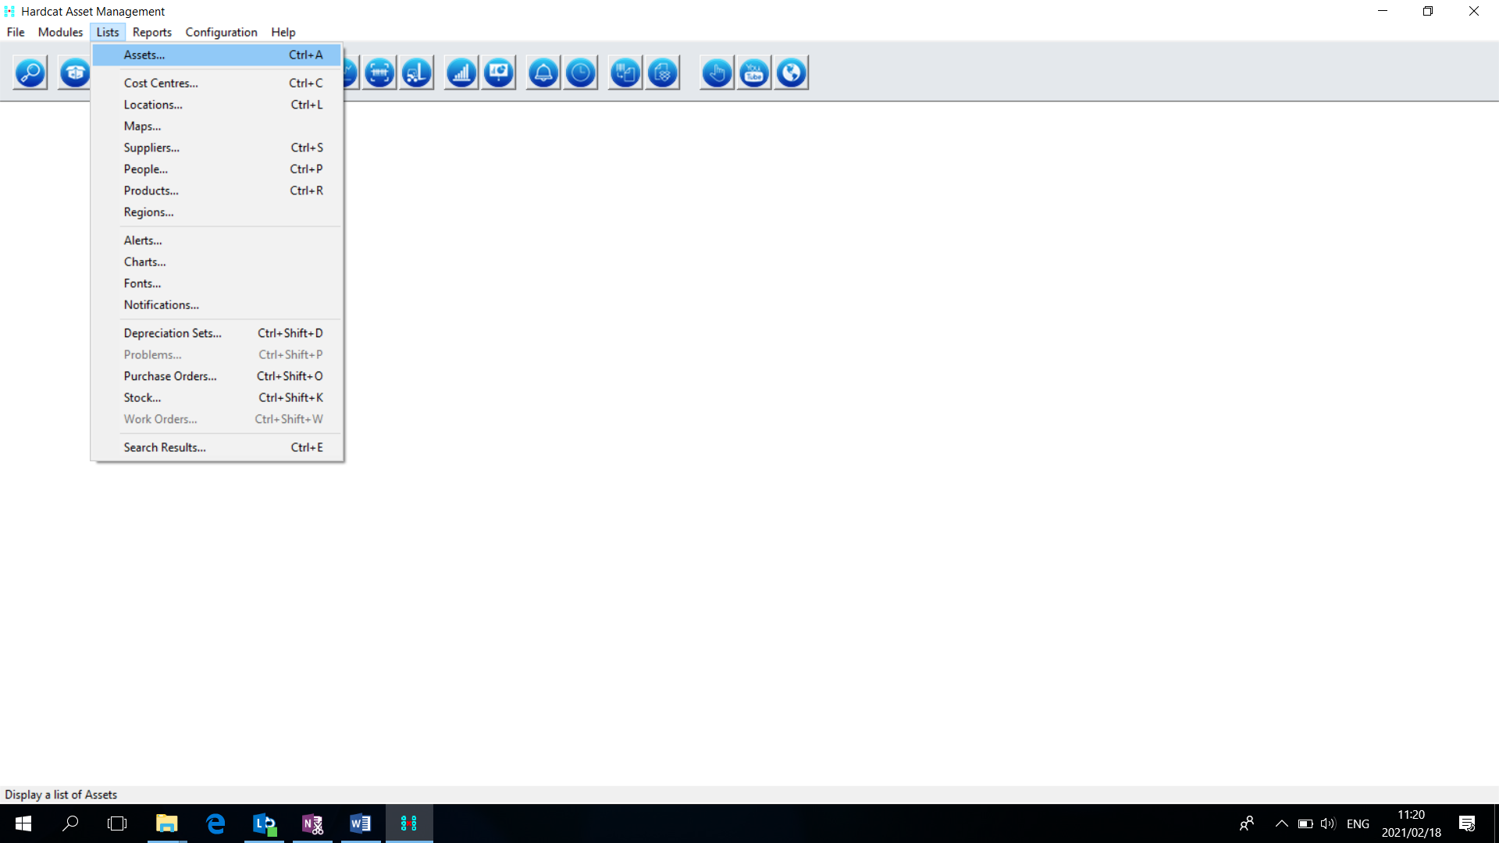

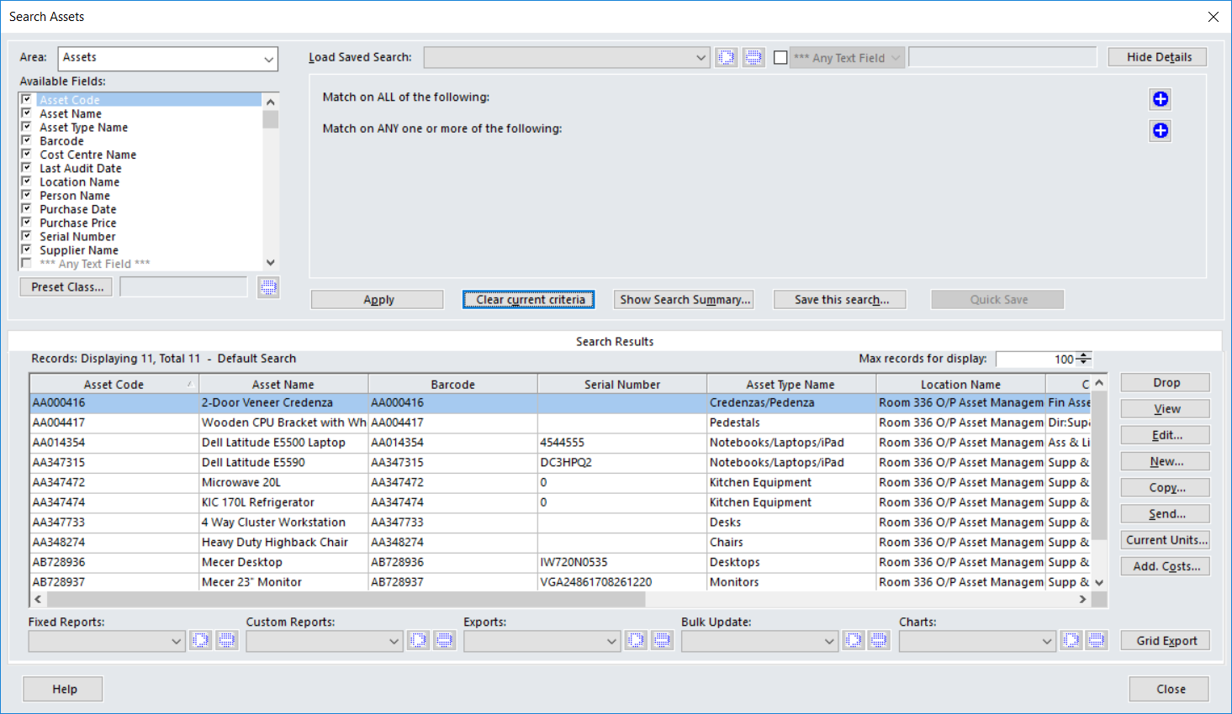
- Click New.
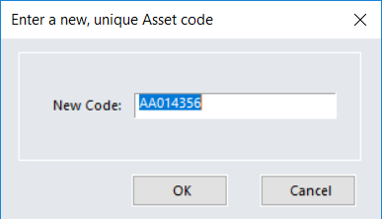

- Enter a new, unique Asset Code (your Barcode)

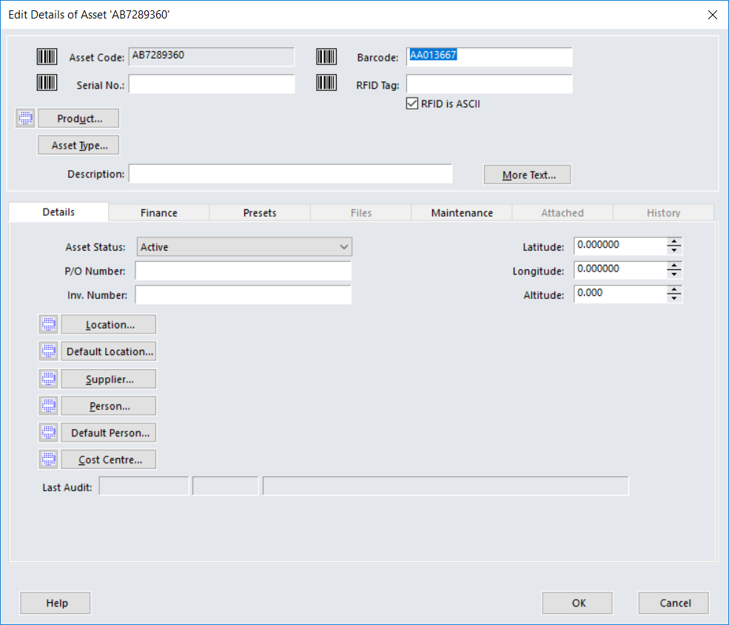
- In the Barcode Box, enter the barcode number. The Asset Code assigned to an asset will never change but the Barcode can change, it is preferable if the asset code is changed to be similar to the barcode.
- Enter the serial number in the Serial No Box.
- Select the Product by clicking on Product Button. This will take you to the list of Products available on Hardcat. Asset type and description will come up automatically.
- Click on the Location Button to select the desired location. This will take you to the List of Locations.
- Click on Supplier Button to select supplier. This will take you to List of Suppliers
- Click on Person Button to choose the user. This will take you to the List of People.
- Click on Cost Centre Button to choose your Responsibility & Objectives. This will take you to the List of Cost Centres.
- Enter the purchase price by typing it in or using the scroll down & up arrows.
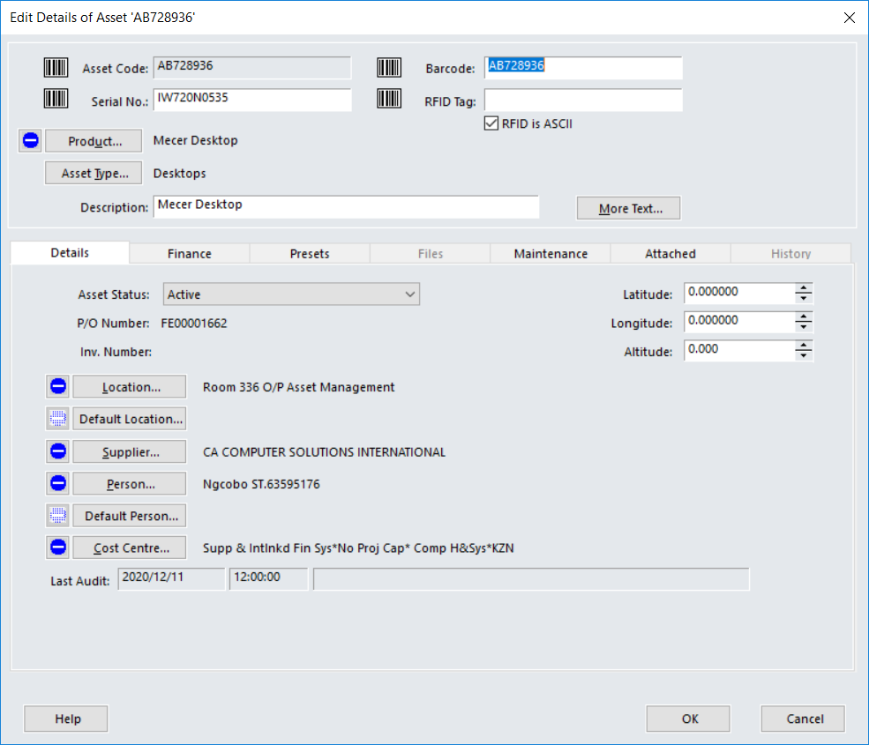

- Creating a Financial Asset Record

Financial detail can be added to the asset after the base record has been entered.
- Select Lists, Assets, or press CTRL-A or click on the List of Assets Icon.
- Move the cursor onto the required asset and click on it to highlight.
- Choose Edit.
- Click on the Finance Tab.
- In the top left hand box select the acquisition status of the asset.
- In the warranty End Date Box, enter the Warranty End date of the asset or click on the Warranty End Date Button and select your date from the calendar. Choose Ok to confirm. This is an optional field.
- The Dep. Start Date will default to the purchase date, you can change the date by selecting the right date from the calendar.
- The Current and Valuation Date boxes are updated through the Depreciation Module.
- In the End of Life Date Box, enter the End of Life date of the asset or click on the End of Life Date Button and select your date from the calendar. Choose OK to confirm. This has no effect on the Depreciation Module.
- Enter the replacement cost of the asset in the Replace Box. This is an optional field.

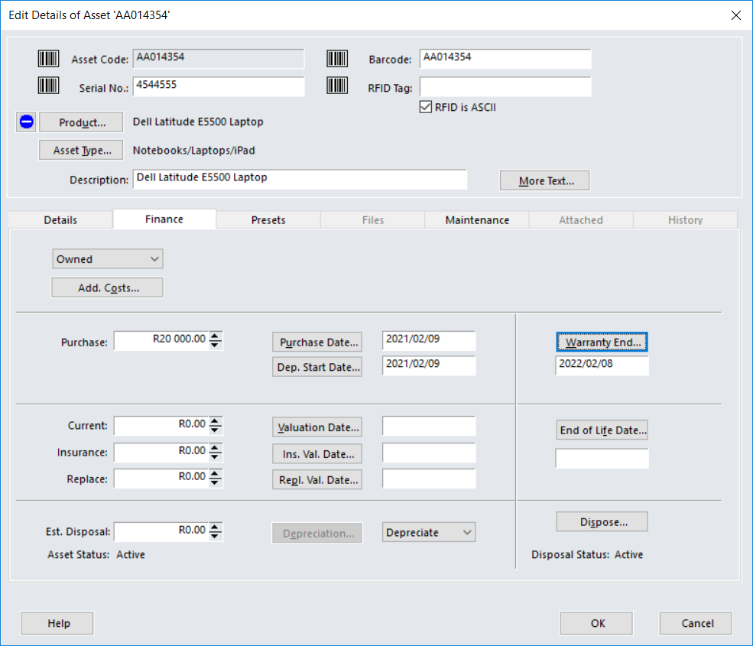
Historical cost/ purchase price. - does not change./decrease
Input this when payment done

Select Depreciate for assets
R 5000 & above. Select “Don’t Depreciate” for assets R 5000 & below.

Date of delivery. Input when asset delivered. Depreciate from date of delivery
Date of payment. Input when payment done

- In the Repl. Val date Box, enter the date the valuation was made or choose the date from calendar.
- The Depreciate Box indicates whether the asset is depreciating or not.
- Click on OK to confirm or click on the Preset Tab to record the Asset Type defined questions.
NB: Disposal of assets is done on the Depreciation Module.

- Recording Asset Preset Information

A Preset Class is comprised of a series of user defined attributes, or ‘Preset Question’s. Presets are used to capture extra information about a specific Asset Type.

- From the Lists Menu, choose Assets.
- Move the cursor on to the asset and click on it to select.
- Choose Edit.
- Click on the Presets Tab.
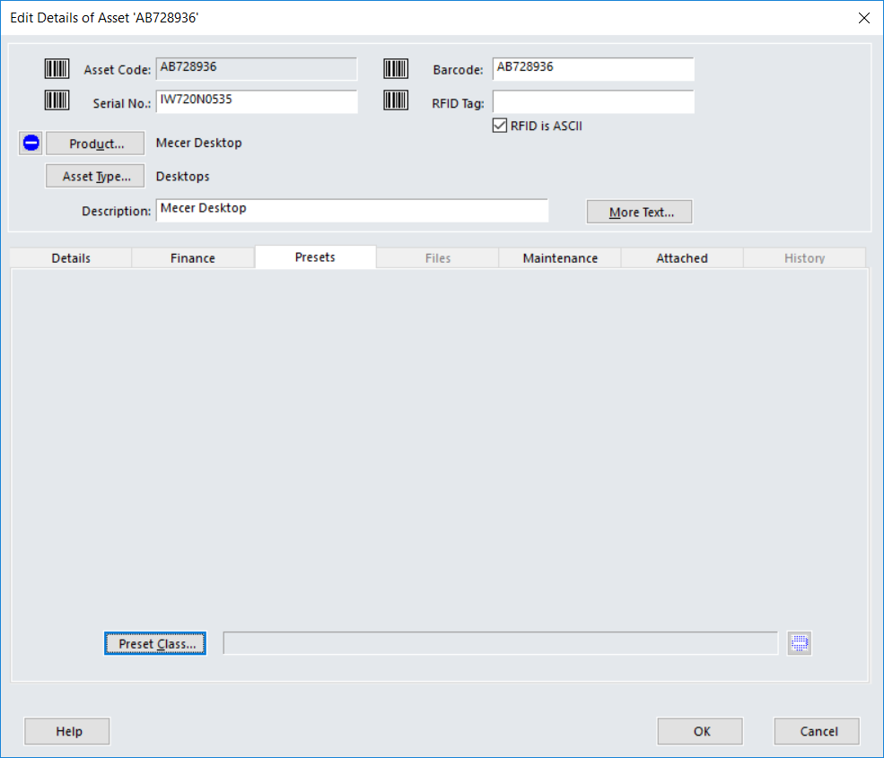
- On each line, enter an answer to the question on the left side of the screen.
- Click on OK to confirm, or click on the Files Tab to attach a file to the asset record.

- Attaching Files

Files can be stored against an Asset, a Product, a Location, a Cost Centre, a Supplier and a Person to provide a reference. Any type of file can be saved. This would help in cases where it is difficult to identify an asset only by its description.

- From the Lists Menu, select Assets.
- Move the cursor onto the asset and click on it to select.
- Choose Edit.
- Click on Files Tab.
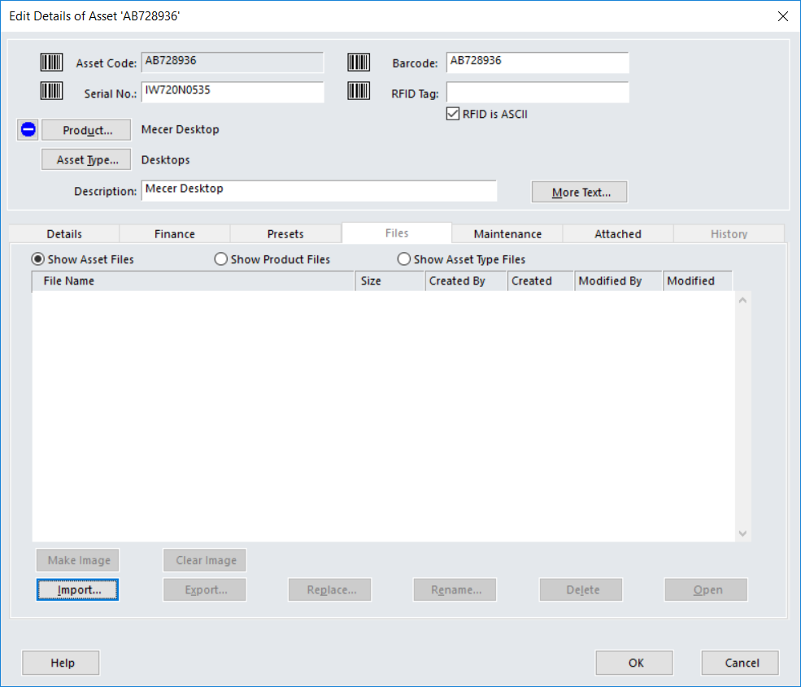
- Click on the “Import’ button.
- Choose OK to confirm, or click on the Maintenance tab to record an asset’s maintenance agreements.

- Monitoring Supplier Maintenance Contracts

Supplier Maintenance contracts can be recorded to enable the identification of the true operating cost of an asset. This information can be used to measure Supplier’s service level agreements and to evaluate replacement assets.
- From the Lists Menu, select Assets.
- Move the cursor onto the asset and click on it to highlight.
- Choose Edit.
- Click on the Maintenance Tab.
- In Cost, enter the cost of the maintenance agreement.
- In Period Box, select the period of the agreement from the drop down pick list (Month, Quarter, Year)
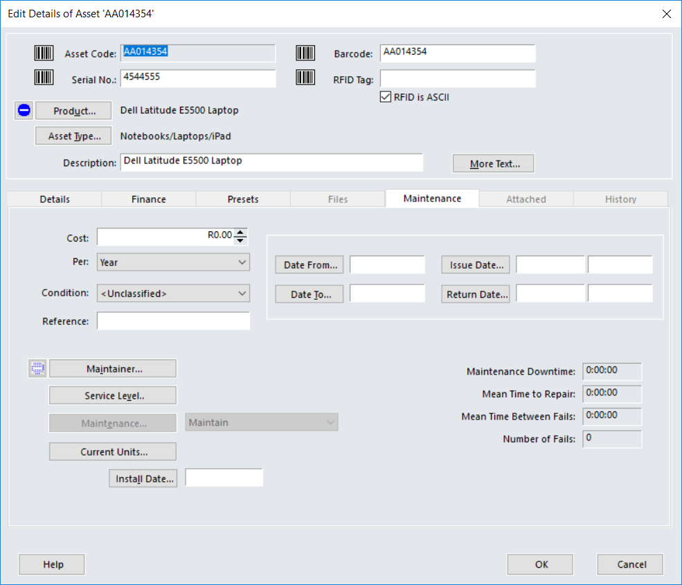
- In Date From… Box, enter the maintenance begin date or click on the Date From… Button and select your date from the calendar.
- In Date To… Box, enter the maintenance end date or click on the Date To… Button and select your date from the calendar.
- The Reference field can be used to record additional information or the contact number.
- Click on the Maintainer Box to select the Supplier. This takes you to the List of Suppliers.
- Enter Issue Date or choose from Calendar option.
- Enter Return Date or choose from Calendar option.
- Select Condition of the Asset from the drop down box.
- Click on Service Level to select applicable service levels. This defines times an asset is expected to be available for use. The Service Level Table is used in the Maintenance Module.
- Click on the Maintenance button to open the Maintenance Details Box. I t displays the following information:
  - Task Code
  - Task Name
  - Last Service Date
  - Next Service Date
- To see further details about a History action, click on Edit Log. Information supplied is Comment, Transaction Type, Logged Entity, Effective Date, Actual Date, User and Description.
- You can enter a comment in the Comment Box, then click OK.

- Hardcat List with built-in Search

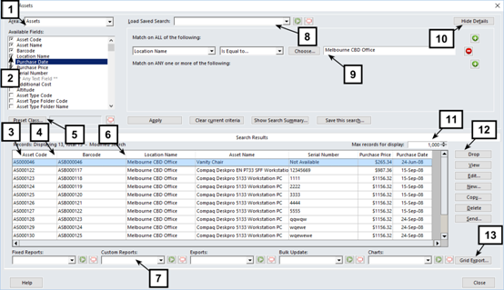

Hardcat lists combines two major functions of search & list into a single user interface thereby making it easy for users to find the data that is relevant to them in just one or two clicks.

The top half of the screen is taken up by the search pane and the bottom half of the screen contains the list. The list, at all times, contains data that matches the search criteria specified at the top.

1. Area
Indicates the area of Hardcat. Hardcat list is available across all areas of Hardcat. Depending on the area chosen, the fields available for search and the functions and options in the screen will differ.
Please refer, for more information.
2. Checkboxes to choose fields for list
You can choose the fields that appears in the list by turning ON the checkboxes against the fields and clicking APPLY.
For example, to have Asset Code appear as a column in the list, turn ON the checkbox against Asset code and click APPLY.
3. Ability to order columns for list
Once you choose the fields for the list, you can set their order of appearance by dragging the columns and dropping them at the required position.

4. Sort Columns
To sort the data in the list by a particular column, simply click on the column header.
For example, to sort the data in the list by Asset Code, click the Asset code column header in the list.
5. Re-Size Columns
Re-size the columns in the grid by clicking on the column border and dragging it.

6. Preset Class Selection
You can select a Preset Class by clicking on the Preset Class button. Once a Preset Class is selected, the questions that are part of the Preset Class become available for selection. This means a user can display a Preset Question as a column in the list.

7. Access to Reports, Exports, Bulk Update & Charts
From the list, you can run fixed reports, custom reports, bulk update specifications & charts related to the particular area by making a selection from the drop down box and clickingà.

8. Load Saved Search
All saved search specifications are presented in a drop down combo box. Make a selection and click à to refresh the data in the list based on pre-saved search criteria.
9. Boolean Search
The Boolean search area is available on all Hardcat lists.
The search area consists of two parts that allow a user to specify a search criterion using the AND and OR search clauses.
10. Show or Hide search pane
You can choose to have the search pane displayed or hidden. To hide the search pane, click on the Hide Details button.

11. Set value for Maximum records in list
This setting specifies the maximum number of records that is displayed in the list at any given time.
For example, if you set a maximum value of ‘1000’, the list will only display 1000 records even if there are more than 1000 records that satisfy the search criteria specified.
This setting is useful if you are concerned about the list load time/performance.

12. Function buttons
The following functions buttons are available on Hardcat lists: New, View, Edit, Copy, Delete, Drop & Send.
The Hardcat lists are context sensitive so the functions buttons that appear on lists in other areas of Hardcat may vary. The functions buttons conform to the security settings on the logged in user.
For e.g., if a user does not have access to create new assets, the NEW button on the list will be greyed out.

See Below for more information.

NEW | Allows users to create new records
View | Allow users to view an existing record
Edit | Allows users to edit a record
Copy | Allows users to create a new record by copying the details of an existing record
Delete | Allows users to delete a record
Send | Provides various output options such as print, save as & email.  For e.g., a user can attach an asset record to an email and send it to their manager.
Drop | Allows users to remove a record from the list.  Note: the record is not ‘deleted’ from the system but is merely removed from the users view and will not be part of any output options such as reports & exports.

13. Grid Export
Allows the user to export the data in the list, as per the search criteria specified in the Boolean search area, directly to file (.csv file format).

11. The List of assets/ Search Assets

This works in conjunction with the Order By key. To find an asset, you must first choose the order by which you want to use on the Match on All of the following or Match on Any one or More of the following. See below screen.

Example: The Asset you are searching for has an asset code that begins with AA347315, on the Match on all of the following select Barcode on the drop down errow is equal, the Put the above Barcode and select apply. See below screen.
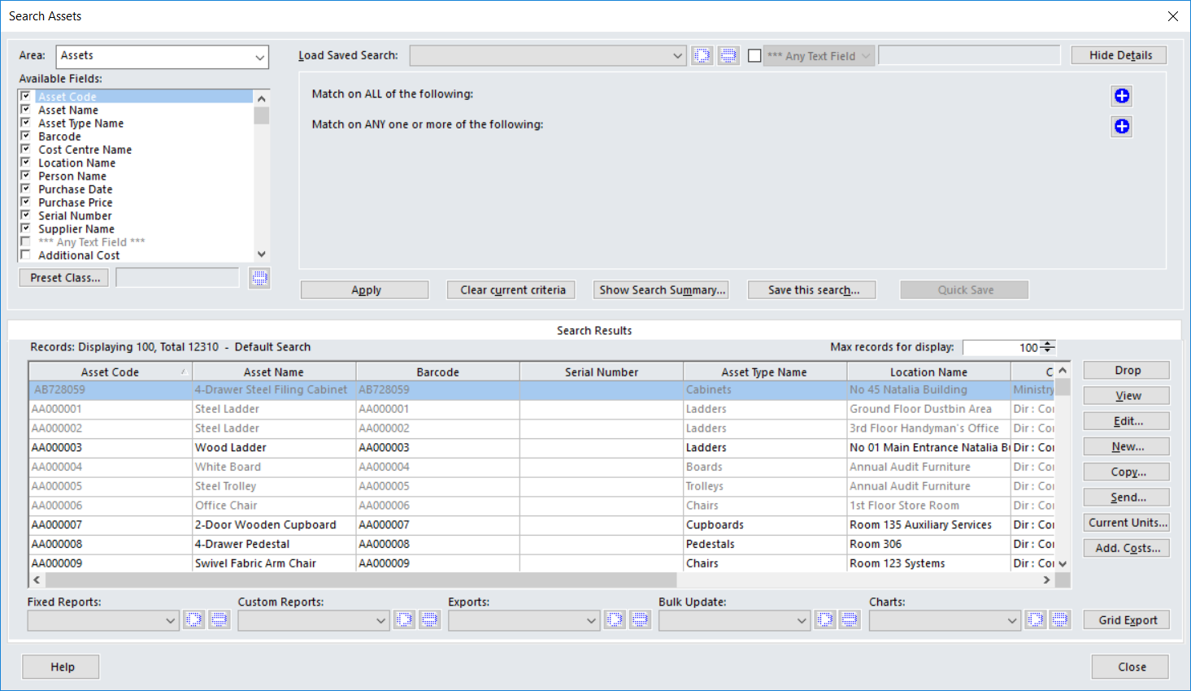

- The Asset Type Key

This feature allows you to show only assets of a specific type in the List of Assets screen.
- From the List of Assets Screen, click on the asset Type Button.
- Choose your Assets Type from your asset Type hierarchy.
- Click on OK to confirm.
- Assets in your List of Assets screen will now be limited to the Asset Type selected.
- To clear, click o all Types button.

- To Find an Asset

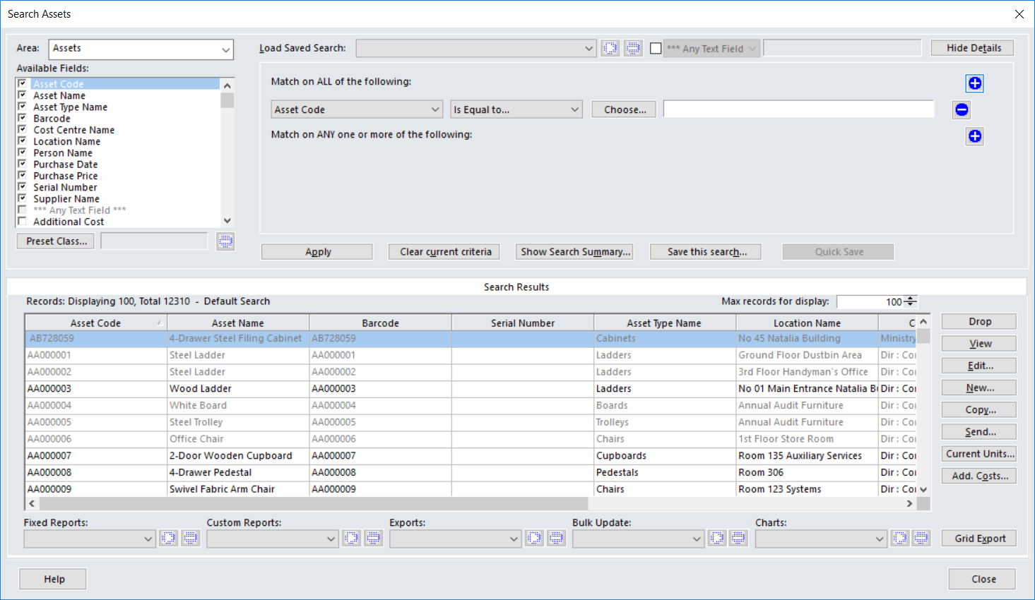

- Enter in your chosen character string in the Match on all of the Following by expanding on plus sign.
- Ensure the Asset List is ordered in the correct sequence.
- Click on Apply.
- View / Edit details of Asset as required.
- To view the entire list again, clear the current criteria, and then click on the Match on all the following plus sign.

- The Copy Key

This is useful if you have more than one asset of the same type that you need to record in Hardcat. By entering all the details for one asset you can then copy those details as many times as you need to.
- Select the Asset you wish to copy by highlighting it.
- Click o the Copy button.
- The exact details will be copied to a new asset, and the new asset will be given a unique asset code.
- The system will allow you to change the Barcode.
- Any other details relating to the asset can then be added at this time, e.g. serial number.

- The Delete Key

An Asset can be deleted from Hardcat using the Delete key. NB: Once an Asset has been deleted it is gone forever. If you try to delete an asset that is depreciating you will be given a warning stating that the asset is currently under depreciation are you sure you wish to delete. The same message will appear if the asset is under maintenance.

- Transfer / Moving assets

- From the Modules Menu select Barcoding.
- Click on Move Assets.

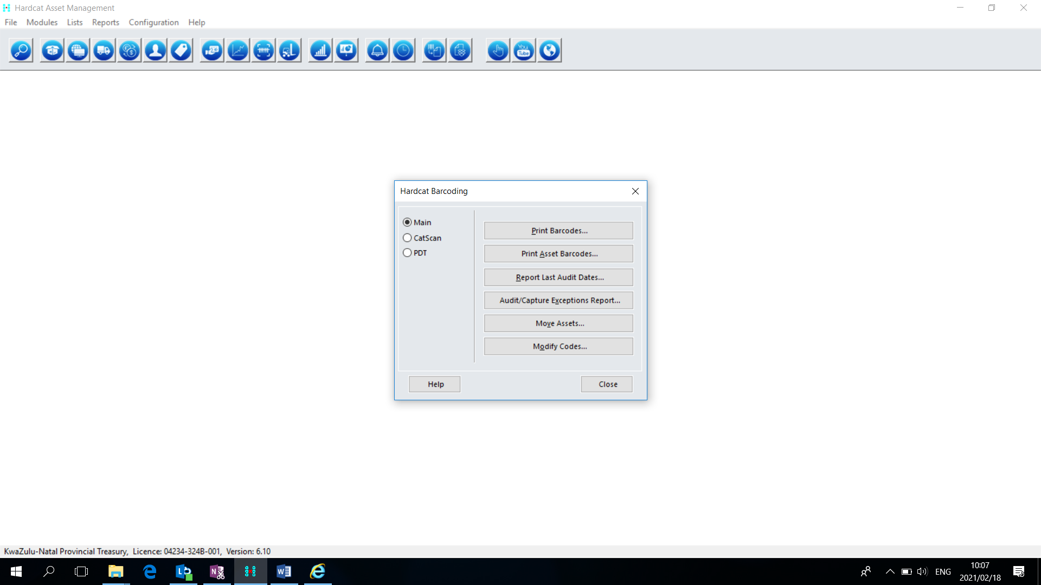

- At the bottom of the screen, there are three options for Destination (Person, Location & Cost Centre) Select the desired destination.
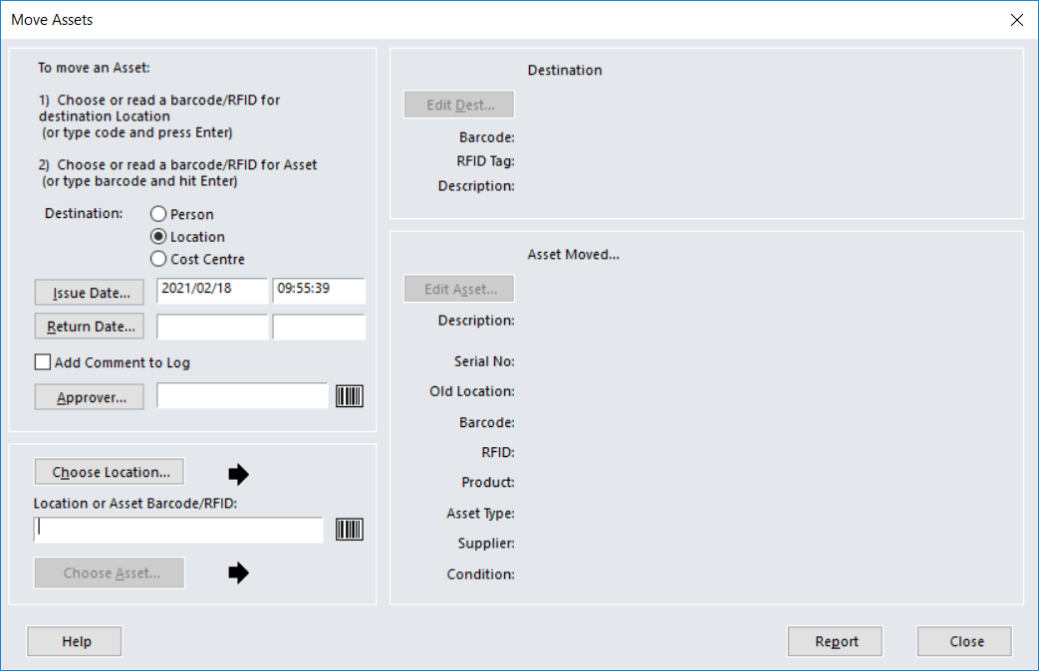
- Select the ‘Choose Location’, ‘Choose Person’, or ‘Choose Cost Centre” option to select asset destination.
- Choose an asset from the list, by selecting ‘Choose Asset’.
- An optional comment of the move may be added by checking the ‘Add Comment to Log’ option. This comment will be added against the assets history details.
- Repeat the asset selection for each asset to be moved to this location.

- Creating an Asset Record via Purchasing Module

- From the Modules Menu select Purchasing.
- Select List of Purchase Orders.
- Select the desired purchase order (only the confirmed order) from the List.
- Click on Deliver.

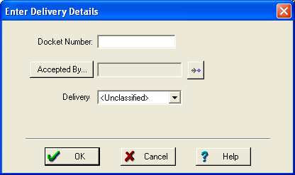

- Enter Delivery Note/Docket number.
- Click on Accepted By. This will take you to the People List. Choose the person who will sign for receipt of asset.
- Click on the drop down box to choose delivery mode.
- Click OK
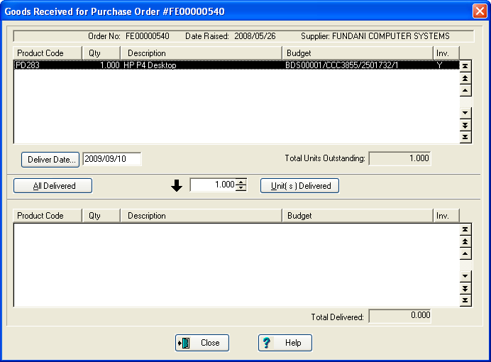

- Enter Delivery Date or click on Delivery Date to choose the date from the calendar. The default date will be current day’s date.
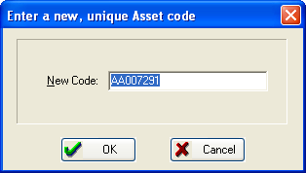

- Click on All Delivered if you have received everything and you will be required to enter a New, Unique Asset Code (preferably your barcode). Or enter the number of unit received.
- Click on OK. This will take you to a screen called New Asset.
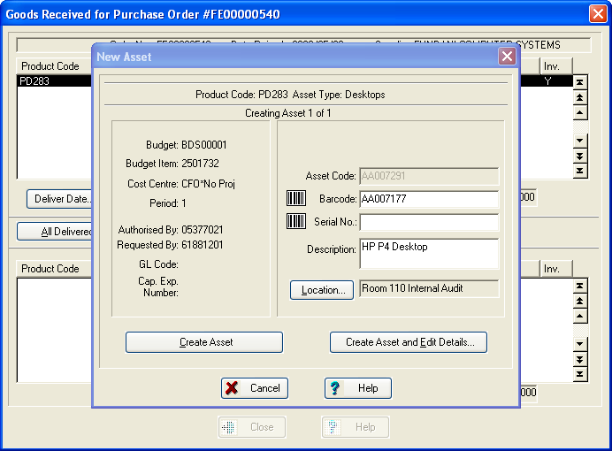
- Enter Barcode number.
- Enter Serial Number if the asset has a serial number.
- Description will come up automatically.
- Location will also come up automatically. You can change the location if it differs.
- If you click on Create Asset an asset record will be created without capturing the financial record. The Financial Record details can be added. This has been covered (Please refer to section: Creating a Financial Record).
If you click on Create Asset and Edit Details, this will enable you to capture some more details for example Financial details, Presets, Supplier Maintenance contract etc. NB: Do not forget to capture the custodian, Purchase amount, Presets and Condition).
The following screen will be populated once the asset has been created:
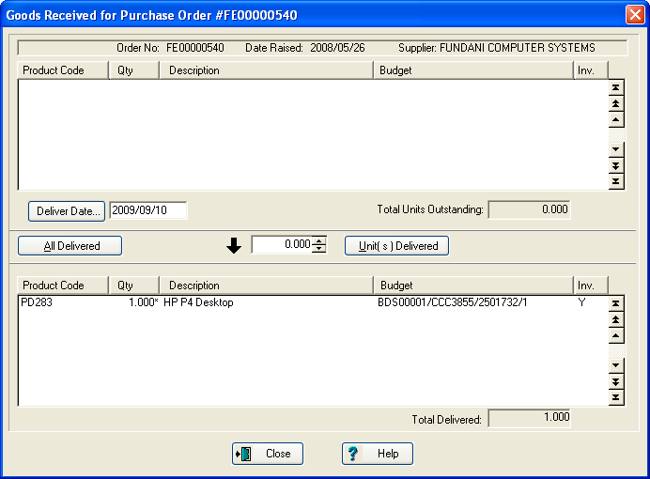

Click close, and it will take you back to the list of purchase orders window, you will then click
close.

17. REPORTS

Reporting Feature
The Software is supplied with a Report Generator. System features include:
- Pre-formatted reports
- Custom report writer tool
- Multiple selection & report sorting
- Report generation to various outputs including printer, screen, file, and email
Reporting can include practically any fields and from virtually any area in the system, e.g. Assets, Suppliers, Locations, Personnel, Help Desk, Cost Centers, Purchasing and Depreciation. A comprehensive query facility is also provided to allow the user to target a particular group of assets for reporting purposes.
Reports specific to asset auditing may be run from the Barcode Module. Standard reports include:
- Data Capture report (showing full details of asset allocation) for new asset items captured with the bar-code reader
- Asset Audit report, comparing asset details on the Hardcat database to the results of the barcode audit and highlighting exceptions such as moved or missing items
- Last Audit Dates report, listing all assets in terms of when they were last audited and last known location

FIXED REPORTS

These reports are standard reports available on the system.

Fixed reports are available on the following selections:

General
Assets
Suppliers
Locations
Cost Centres
People
Products

Reports specific to assets are as follows:

Click Reports, click Assets, and choose the report from the list populated:

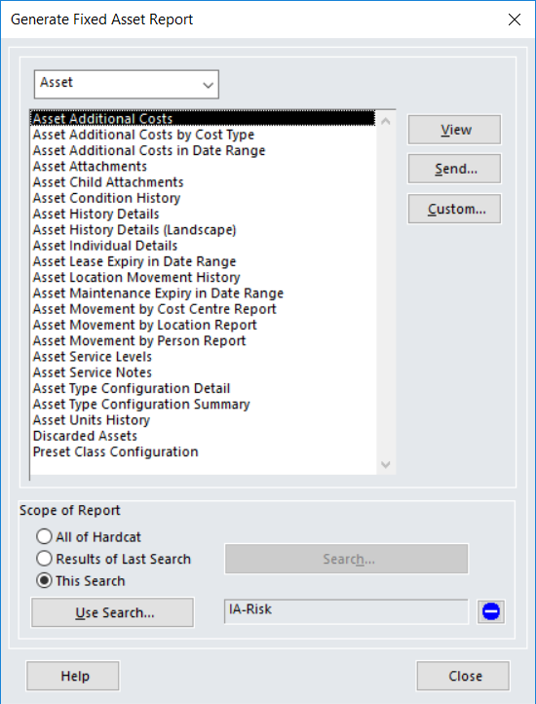

Asset reports can also be customized (refer Hardcat Reports user guide)

Boolean Search Area

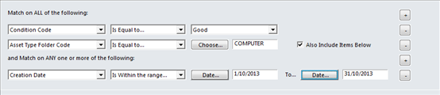

- The Boolean search area is available on all Hardcat lists.

- The search area consists of two parts that allow a user to specify a search criterion using the AND and OR search clauses:

AND

- The part of the search screen that performs an AND operation is titled ‘Match on ALL of the following’
- AND means that both items must be present.
    - E.g., Display all assets where ‘Asset Type Folder Code’ = COMPUTER AND Condition Code = GOOD.
OR

- The part of the search screen that performs an OR operation is titled ‘Match on ANY one or more of the following’
- OR means that any one of the conditions specified must be present
    - E.g., Display all assets where ‘Asset Type Folder Code = COMPUTER OR Condition Code = GOOD
- A user can create any number of search criteria within the AND or OR sections by clicking on the button on the search screen.
- To remove a search criterion, simply click on the button against the search criterion.

Defining a Search Selection

This facility allows you to define the search criteria. The search selections can be saved for future use.
1. To perform a Search, click on the Search icon on the Hardcat toolbar, or access the search area from any Hardcat entity list screens. You can also launch a search by clicking on the ‘Results of last search’ button from the Reporting section of Hardcat.
2. Depending on where you have entered the search facility from, you may have the choice to select ‘Area’ of Hardcat you wish to search on. You can make your selection from the ‘Area’ drop down box.
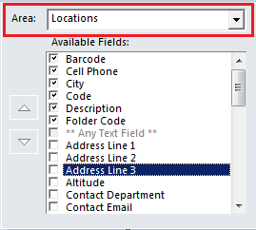
3. As you go through the different Areas of Hardcat, you will notice that the fields available for search changes in the Dialog box.
4. Once an ‘Area’ is selected you can create the actual search criteria.
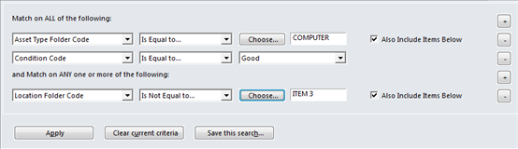

5. To remove a field from the search, click on the button
6. To add a new field to the search, click on the button
7. Once you have created your search criteria, click on APPLY
8. Before starting a new search, click on ‘Clear Current Criteria’. You will notice that the summary box is reset. (If you do not clear the current criteria the search will include the criteria used previously and will add the new criteria to the Search.)
Related Topics

